1. 2D Convolution: Both images shown for images convolved by self convolved function as well as inbuilt function.

Time Gx: 2.89700055122,

Time Gy: 2.78899884224

Total : 5.68599939346

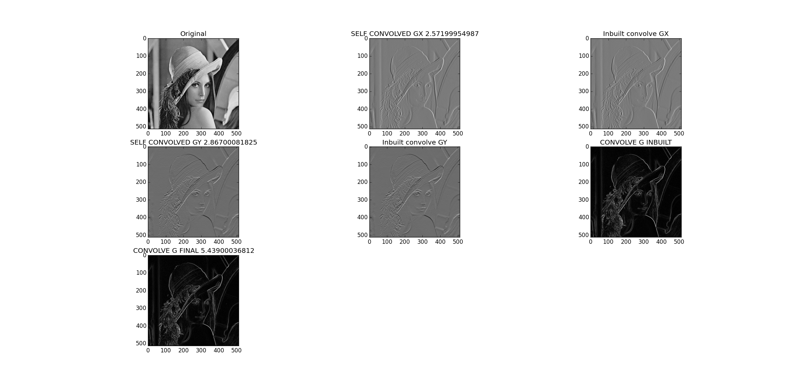

2) 1D filter convolution: Both way show by self convolved as well as inbuilt. Starting from 1st GxA 1D filter then calculating GxB by using the result of GxA. Similarly GyB using the result of GyA. Then the final G by GxB and GyB.

Multiplication time till GxA : 0.685000181198

Multiplication time till GxB : 0.466000080109

Multiplication time till GyA : 0.532999753952

Multiplication time till GyB : 0.540000200272

Multiplication time till Total : 2.22400021553

Results are same via 1D as well as 2D

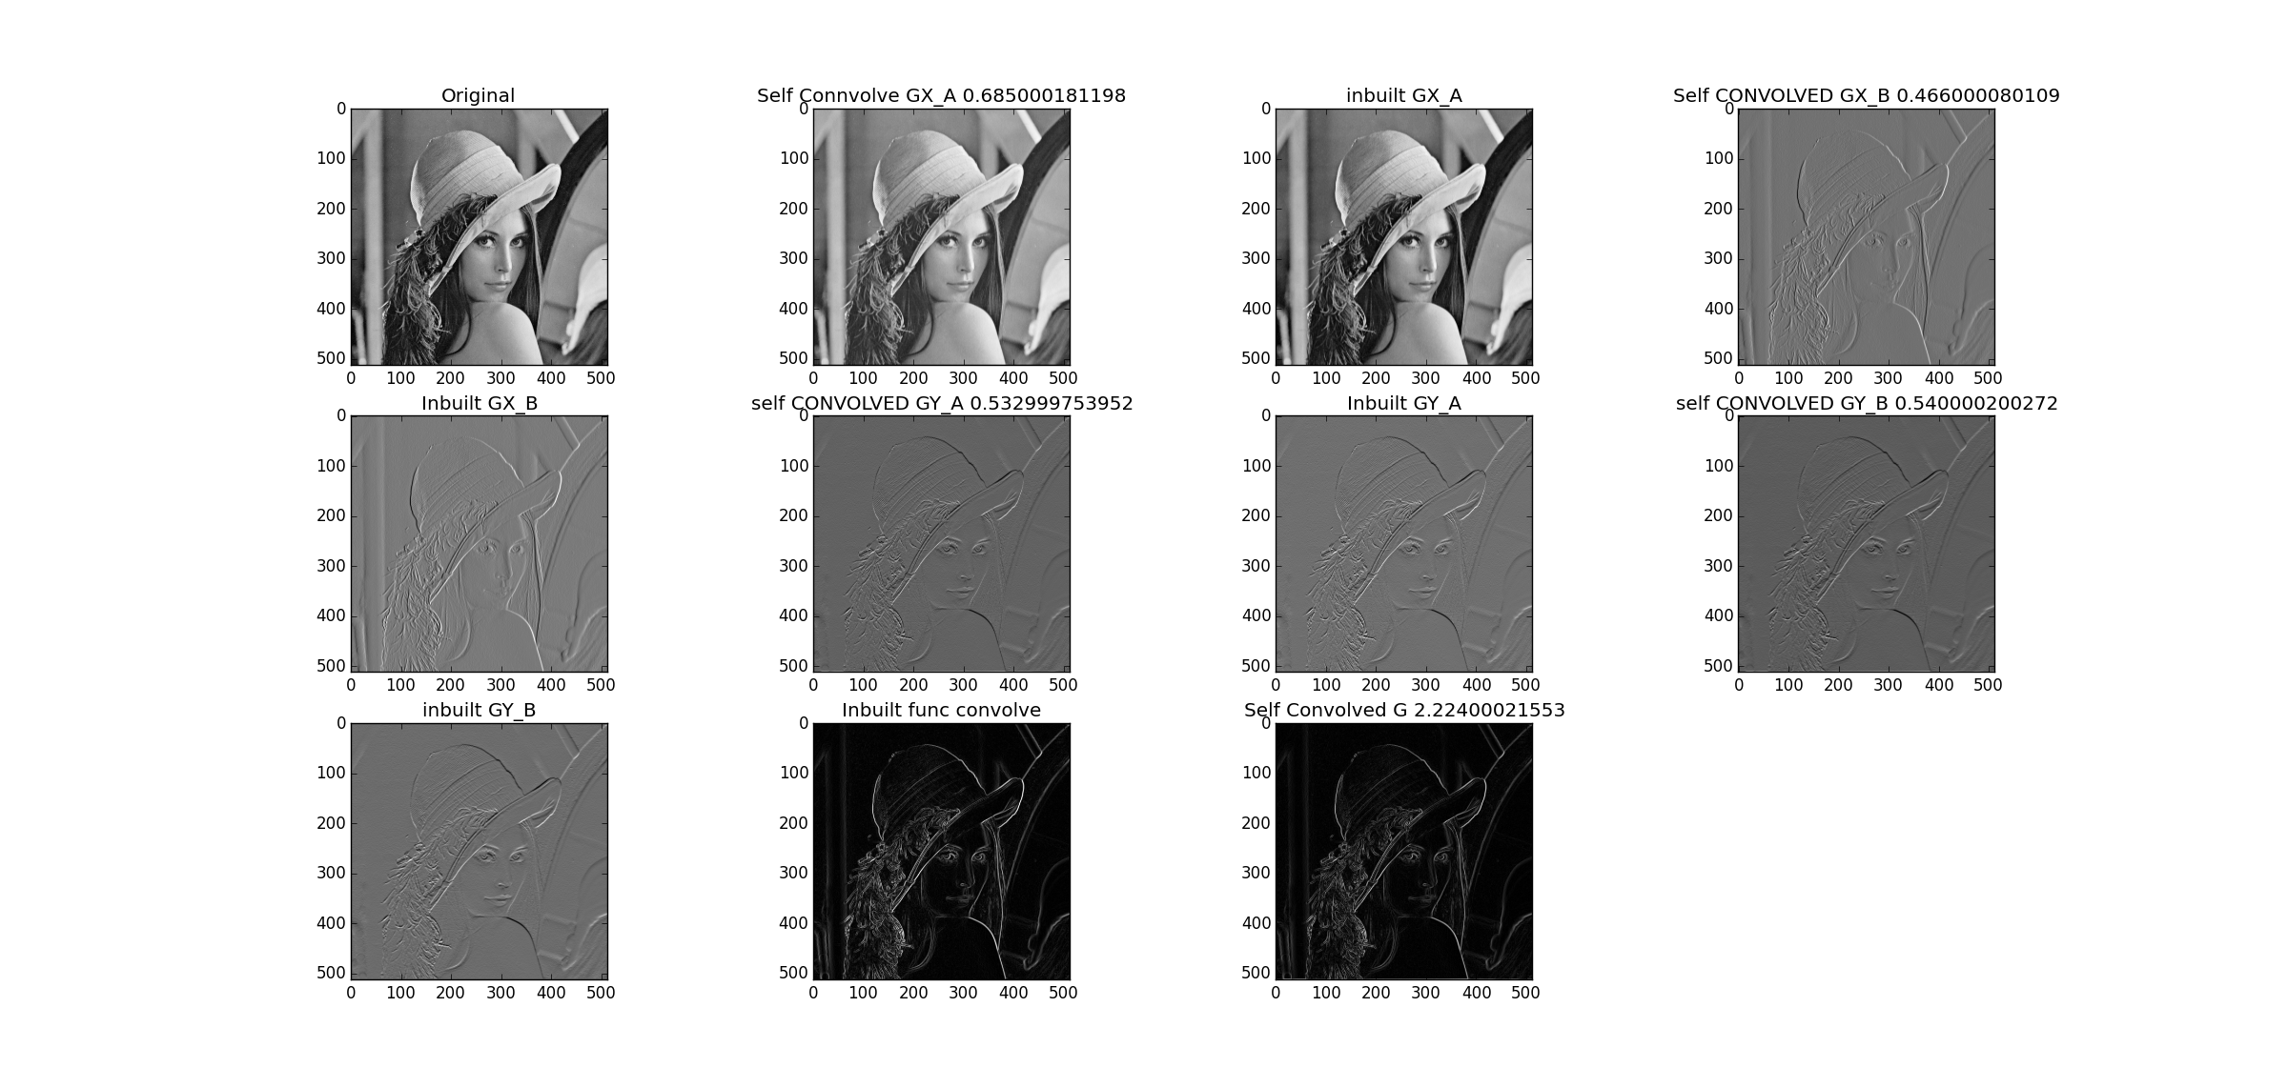

3) As shown above  
Total time by two 2D s Convolution  
5.68599939346

Total time of multiplication by Four 1D s

2.22400021553

As there are lesser number of multiplications the time of four 1Ds to calculate in part b is lesser than from two 2D s kernel convolved multiplications.

Q2  
1) 3 images everything step by step on the plot diag  
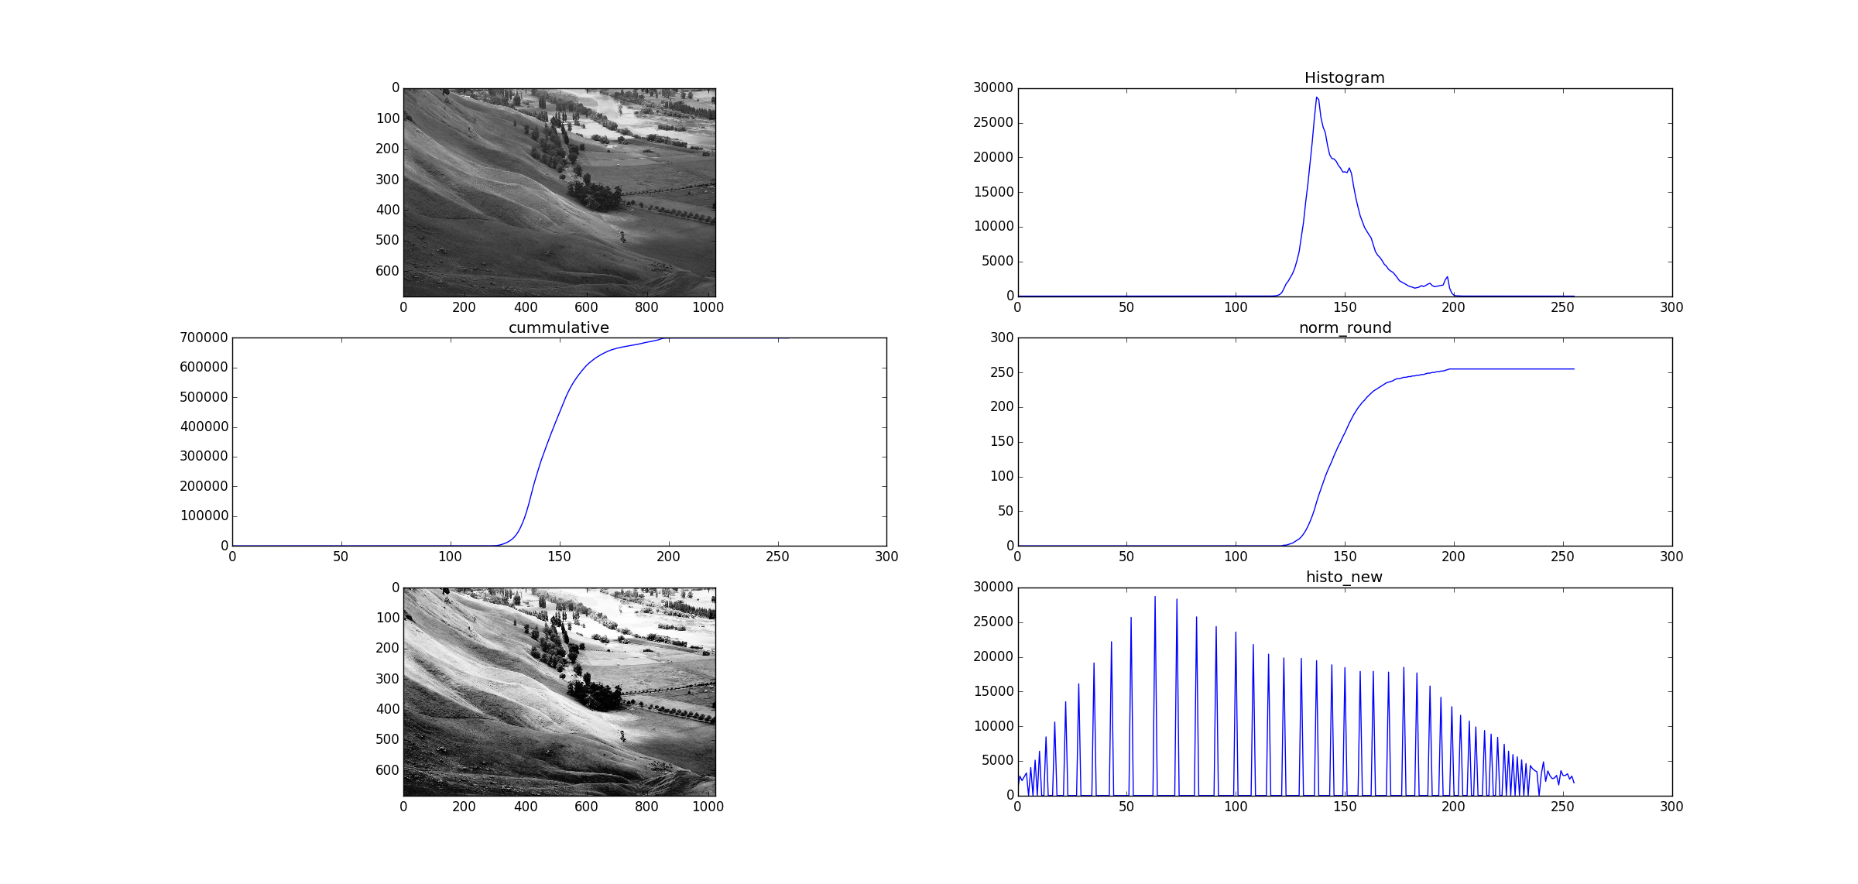

2) Histogram difference with enhanced version

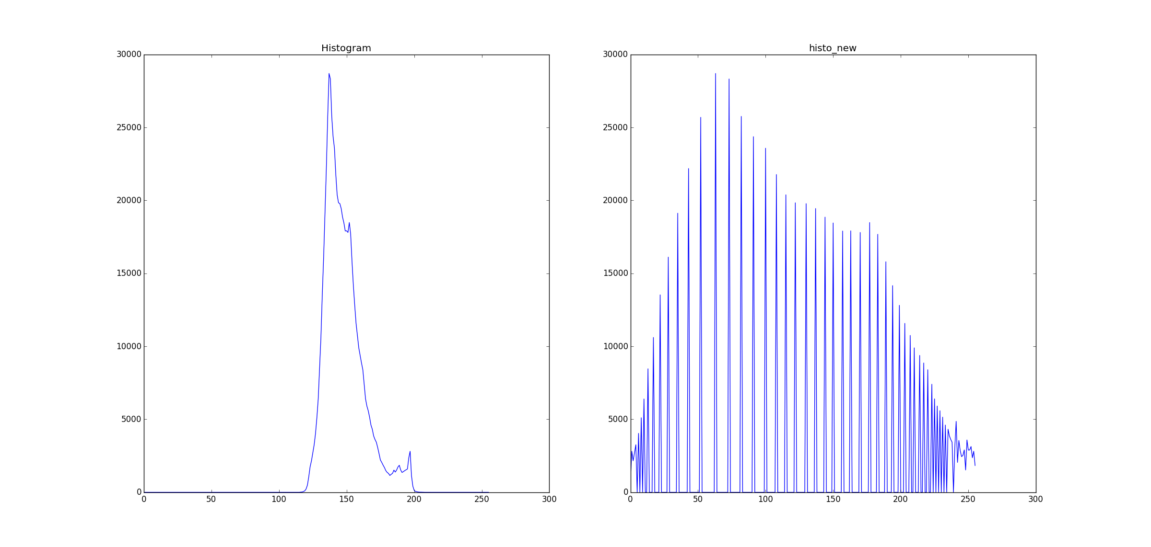

3) Image improvement side by side

